Project Explanations

Project 1:

Objective:
The purpose of this project is to design a parallel circuit and calculate total current and current through each resistor.

Components Used:
- DC Battery (9V)
- Resistors:
  - R1 = 10kΩ
  - R2 = 2kΩ
  - R3 = 1kΩ
- Connecting wires

Steps to Create Circuit in Proteus:
- Open Proteus software and create a New Project.
- Enter the project name and continue with default settings.
- Click on Pick Devices (P).
- Search and select:
  - Resistor
  - DC Battery
- Place all components on the workspace.
- Set resistor values:
  - R1 = 10kΩ
  - R2 = 2kΩ
  - R3 = 1kΩ
- Set battery voltage to 9V.
- Connect all resistors in parallel (all one ends connected together and other ends connected together).
- Connect the parallel network across the battery.
- Complete wiring properly and run the simulation.

Calculations:
Formula for Parallel Resistance:
1 / R_total = (1/R1) + (1/R2) + (1/R3)
1 / R_total = (1/10k) + (1/2k) + (1/1k)
1 / R_total = 0.0001 + 0.0005 + 0.001 = 0.0016
R_total = 625Ω
Total Current:
I_total = V / R
I_total = 9V / 625Ω ≈ 14.4 mA

Current through each resistor:
I1 = V / R1 = 9V / 10kΩ = 0.9 mA
I2 = V / R2 = 9V / 2kΩ = 4.5 mA
I3 = V / R3 = 9V / 1kΩ = 9 mA

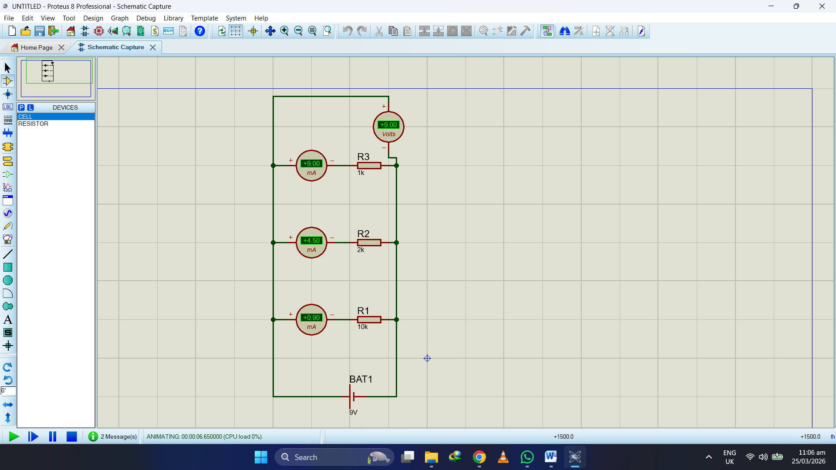

Project 2:

Objective:
The purpose of this project is to design a parallel circuit with four resistors and calculate total resistance and current distribution.

Components Used:
- DC Battery (9V)
- Resistors:
  - R1 = 100Ω
  - R2 = 3kΩ
  - R3 = 5kΩ
  - R4 = 10kΩ
- Connecting wires

Steps to Create Circuit in Proteus:
- Open Proteus and create a New Project.
- Enter project details and proceed with default options.
- Click on Pick Devices (P).
- Search and select:
  - Resistor
  - DC Battery
- Place all components on the workspace.
- Set resistor values:
  - R1 = 100Ω
  - R2 = 3kΩ
  - R3 = 5kΩ
  - R4 = 10kΩ
- Set battery voltage to 9V.
- Connect all resistors in parallel configuration.
- Connect the circuit across the battery terminals.
- Check connections and run simulation.

Calculations:
Formula for Parallel Resistance:
1 / R_total = (1/R1) + (1/R2) + (1/R3) + (1/R4)
1 / R_total = (1/100) + (1/3000) + (1/5000) + (1/10000)
1 / R_total = 0.01 + 0.00033 + 0.0002 + 0.0001 ≈ 0.01063
R_total ≈ 94Ω (approx)
Total Current:
I_total = V / R
I_total = 9V / 94Ω ≈ 95.7 mA

Current through each resistor:
I1 = 9V / 100Ω = 90 mA
I2 = 9V / 3kΩ = 3 mA
I3 = 9V / 5kΩ = 1.8 mA
I4 = 9V / 10kΩ = 0.9 mA
